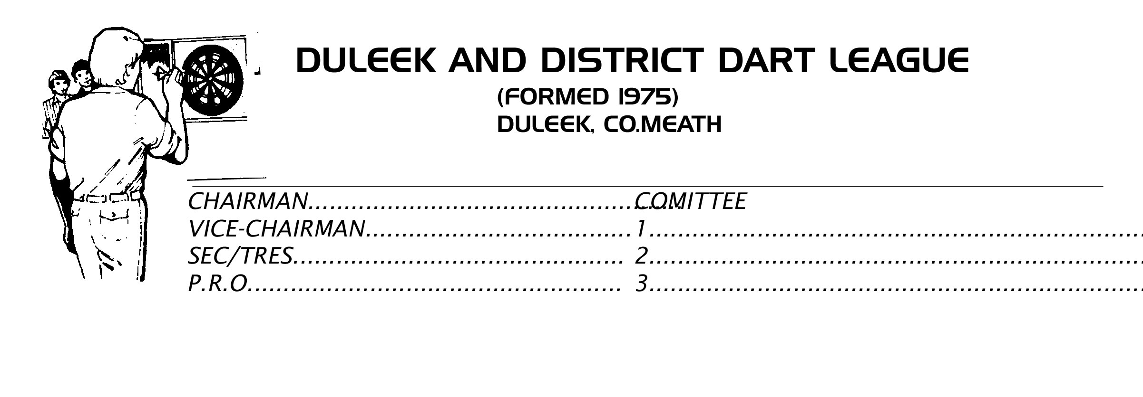
LIST OF ENTRIES FOR DOUBLES COMPETITION
ENTRIES FROM -
Competition to be held in D Hotel Drogheda;
On Sunday 12th March 2023;

Deadline for entries is Thursday 9th March;

Draw in Pheasent Bar, Drogheda, 8/30. Same Night.
REGISTRATION DEADLINE ON DAY; 1-30.PM –
COMPETITION STARTS 2. P.M – SHARP –
ENTRY FEE €10 _Per Player;

